# Setting up environment

Tasks:

1. Setup local Kubernetes instance (Docker Desktop)
2. Create DockerHub account if account doesn’t exist yet
3. Create GitHub account if account doesn’t exist yet
4. Install k9s tool  
   <https://k9scli.io/>
5. Install Kubernetes Dashboard   
   <https://kubernetes.io/docs/tasks/access-application-cluster/web-ui-dashboard/>
6. Create namespace istio-system
7. Install helm tool   
   <https://helm.sh/docs/intro/install/>
8. Install istio via helm:   
   <https://istio.io/docs/setup/install/helm/>,   
   <https://istio.io/docs/setup/platform-setup/docker/>
   1. Enable Kiali in helm template during installation <https://istio.io/docs/tasks/telemetry/kiali/>.
   2. Deploy Kiali secrets Project folder\kiali\kiali-secrets.yml
   3. Configure Zipkin tracing  
       <https://istio.io/docs/tasks/observability/distributed-tracing/zipkin/>

Checklist:

1. Docker Desktop is installed to the local machine
2. K9S tool is installed
3. Kubernetes Dashboard is installed
4. Helm is installed to the local machine
5. Istio-system namespace and its pods created
6. Kiali is tool is installed to the cluster
7. Zipkin is installed to the istio-system namespace
8. DockerHub account exists
9. GitHub account exists

Check istio installation:

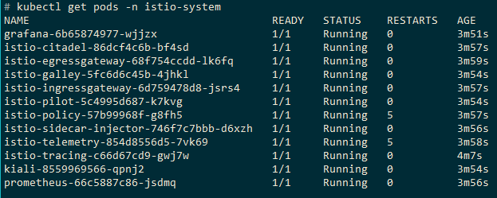

Learning:

1. Overview of the Istio architecture and its components (<https://istio.io/docs/concepts/what-is-istio/>)
2. Sidecar pattern (<https://docs.microsoft.com/en-us/azure/architecture/patterns/sidecar>)
3. Ambassador pattern (<https://docs.microsoft.com/en-us/azure/architecture/patterns/ambassador>)